Least-Cost Holonomy and Co-Distinction Fields
The Shields Field of Distinct Actions: Its Definition, Its Cohomology, and the Least-Cost Selection Principle
Complete Field Programme · Visual Maps · Ensemble Diagnostics · General-Relativistic Coupling
Joseph Shields
Working paper and computational supplement · 28 July 2026
This paper formalises “Least-Cost Holonomy and Co-Distinction Fields: cyclic encoding, radiative distinction and self-organising field dynamics”. The earlier draft introduced a field that has no standard name and gave it an operational description. This one defines it, proves when it admits a potential, and identifies the physical condition under which it does not.
The paper is in two halves separated by a printed line. Parts One to Five use standard differential geometry, cohomology and radiative transfer, and stand or fall on that. Part Six is an extension in the author's own framework, Unified Mechanics, and is offered as interpretation. Nothing above the line depends on anything below it.
A difference between two places is not a quantity at a place. Whether it can be made into one is a question with an answer, and the answer is not always yes.

Abstract
A closed cycle in a system's internal configuration space can produce a net external displacement. This is geometric phase, and it is the mathematical basis for shape-change locomotion. The earlier draft proposed reading such a cycle as an encoder: the loop carries a required invariant into an observable output, and a variational principle selects the least-cost loop realising it. That proposal is retained and sharpened here.
The paper's new content is the definition of the second object the draft introduced and did not define. It is named here the Shields field of distinct actions, and it is not a scalar field. It is an antisymmetric two-point function 𝒟(x,y) = −𝒟(y,x) whose positive and negative orientations are the two descriptions “lighter” and “darker”, generated together by one relation. Formally it is a one-cochain, and the question of whether the pair description can be replaced by a single-point radiance L with 𝒟(x,y) = L(x) − L(y) is a cohomology question with a sharp answer.
Theorem: on a connected domain, a co-distinction field admits a radiance potential if and only if it satisfies the cocycle condition 𝒟(x,y) + 𝒟(y,z) + 𝒟(z,x) = 0 on every triple. The smooth form of the same statement is that the associated one-form is exact, with obstruction the class in the first cohomology of the domain.
The physical reading of the obstruction is the paper's second result. Transport between two points is path-independent in a purely absorbing medium and path-dependent under scattering, because radiation reaches a point from another by many routes with different optical depths. Scattering is therefore not merely a loss of directional distinction, as the draft recorded. It is the curvature of the co-distinction field, and it is exactly what obstructs the existence of a scalar radiance.
Two further results follow. The interrogative feedback loop, in which a cyclic encoder emits, the environment transforms, and the returned contrast selects the next cycle, is shown to be an operation under which the constant-holonomy class is not stable, so the least-cost principle must be stated on a refined class. And Part Six identifies the same obstruction in four separate constructions of the author's programme.
Keywords: geometric phase; holonomy; connection and curvature; co-distinction; one-cochain; cocycle condition; de Rham cohomology; radiative transfer; scattering; least-cost selection.

Part I · Cycles That Carry

1. The motivating structure
Two motions can produce the same externally recognisable result while distributing motion very differently across a system's internal degrees of freedom. The useful hypothesis is not that a circle is shorter than a line. It is that two actions equivalent at the task level may have very different lengths, energies or smoothness costs when measured in the system's internal configuration space.
Replace joints and muscles with internal coordinates a = (a¹,…,aⁿ) and observable output X = (X¹,…,Xᵐ). The question becomes which closed path through a-space produces the required change in X-space at the lowest admissible cost.
Four distinctions keep this honest, and they are stated here so they are not silently dropped later. Shortest is not always fastest, since the optimising functional decides the geometry and the brachistochrone is curved for that reason. Stationary action is not always minimal, so “least cost” is licensed only after the functional is shown to have a minimum in the admissible class. Constant momentum does not by itself produce an angular variable; phase becomes the economical coordinate when the system is recurrent or bound. And internal closure can coexist with external change.
a(T) = a(0), but X(T) ≠ X(0).
That last line is the structure everything else rests on.

2. Connection, holonomy, curvature
Let a local coupling A^α_i(a) map small internal changes to output changes, dX^α = A^α_i(a) da^i. For a closed internal loop γ the net output is the line integral
ΔX^α = ∮_γ A^α_i(a) da^i,
and in the Abelian or approximately commuting setting Stokes' theorem relates it to the curvature enclosed:
ΔX^α = ∬_Σ F^α_ij da^i ∧ da^j, F^α_ij = ∂_i A^α_j − ∂_j A^α_i.
For two internal coordinates with constant coupling B and dX = ½B(u dv − v du), Green's theorem gives ΔX = B · Area(γ) exactly. The loop returns to the same internal state and leaves a net external result. The enclosed area is not empty geometry; under the connection it measures accumulated output.
Terminological discipline. “Encoding” is used operationally: a controlled internal trajectory realises a required invariant or output. It becomes information theory only after a message space, an equivalence rule and a distortion measure are supplied. Nothing below assumes that step has been taken.
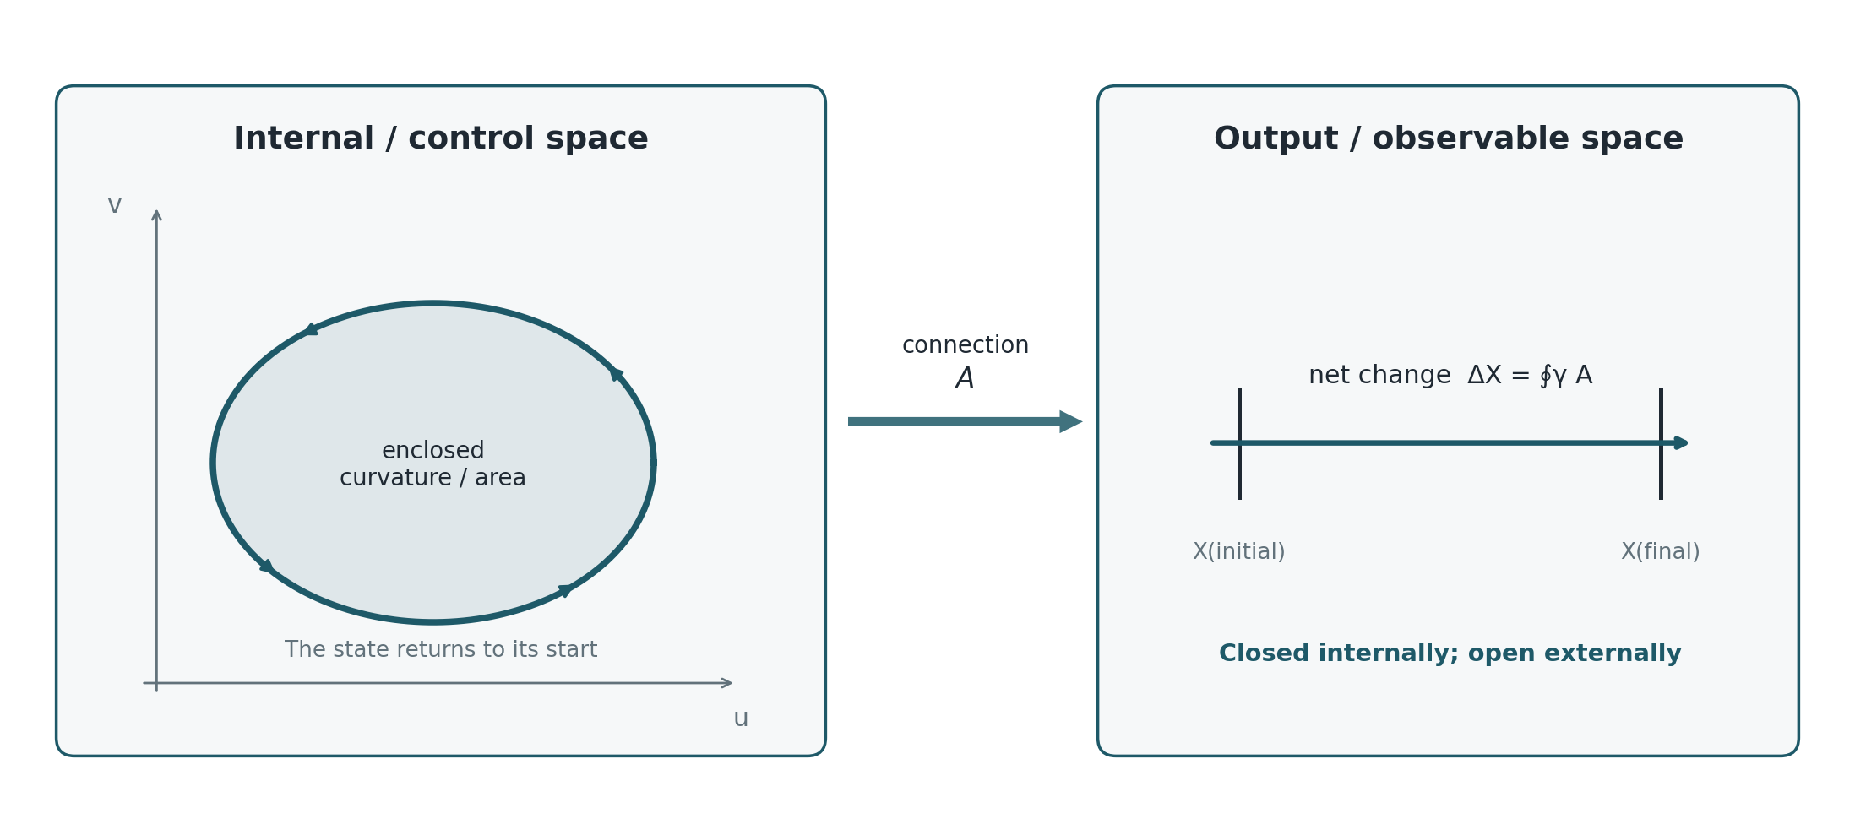
Figure 1. A closed loop in internal or control space accumulates an open displacement in output space through a connection.

Part II · The Fields, Defined

3. Three fields, and which one is new
The framework uses three field objects. Two are standard and are named here only so that the third can be stated precisely against them.
Field | Object | Status
φ(x,t) | real scalar on spacetime; the least-action background whose localised closures are the structures of interest | standard scalar field
ψ = R e^{iθ} | section of a complex line bundle with connection A; the phase θ is the internal cycle coordinate | standard, and the reading of θ as a continuum of local cyclic encoders is the reinterpretation
𝒟(x,y) | antisymmetric two-point function; the Shields field of distinct actions | new as a named object; the machinery below is standard

The first two are fields in the ordinary sense: a value is attached to each point. The third is not, and that is the whole point of it. A co-distinction attaches a value to each ordered pair of points, and it is antisymmetric under exchange. Light and darkness are its two orientations rather than two substances.

4. The Shields field of distinct actions
The object defined in this section is named the Shields field of distinct actions, and the name is chosen against the descriptive alternative. It is not a field of least action, because it does not assign a magnitude to be minimised at a point. Its primitive is the distinction between two admissible actions, held as one antisymmetric relation whose two orientations are co-produced. Where the difference between two actions composes across chains it collapses to a field of least action in the ordinary sense, and Section 5 says exactly when. Where it does not compose, the distinction is the whole of what exists, and there is no per-point action to be least. The shorter form co-distinction field is used interchangeably below.
Definition 4.1 (Shields field of distinct actions; co-distinction field). Let M be a connected domain and V a real vector space. A co-distinction field on M with values in V is a map 𝒟 : M × M → V satisfying 𝒟(x,y) = −𝒟(y,x) for all x, y. For the radiative case V = ℝ and the two orientations are read as “x is lighter than y” when 𝒟(x,y) > 0 and “x is darker than y” when 𝒟(x,y) < 0.
The antisymmetry is the formal content of the claim that the two descriptions are generated together. Reversing the comparison reverses the sign, so neither orientation is prior, and neither exists without the other being available.
Definition 4.2 (Potentiated field; the least-action reduction). 𝒟 is potentiated, or exact, if there exists L : M → V with 𝒟(x,y) = L(x) − L(y) for all x, y. L is then a potential for 𝒟, unique up to an additive constant, and is the radiance potential in the radiative case. A potentiated Shields field is precisely one that reduces to a field of least action: a single magnitude per point, of which every distinction is a difference.
A potentiated co-distinction can be replaced without loss by an ordinary scalar field. An unpotentiated one cannot, and the distinction is not a matter of convenience. It decides whether the phrase “the brightness at x” refers to anything.
Definition 4.3 (Cocycle condition). 𝒟 satisfies the cocycle condition if 𝒟(x,y) + 𝒟(y,z) + 𝒟(z,x) = 0 for every triple x, y, z in M.

5. When a co-distinction admits a radiance
Theorem 5.1. Let M be connected and 𝒟 a co-distinction field on M. Then 𝒟 is potentiated if and only if it satisfies the cocycle condition.
Proof. If 𝒟(x,y) = L(x) − L(y) then the three terms of the cocycle telescope to zero, giving necessity. Conversely, assume the cocycle condition, fix a basepoint x₀ and define L(x) := 𝒟(x,x₀). Then for any x, y the cocycle on the triple (x,y,x₀) gives 𝒟(x,y) + 𝒟(y,x₀) + 𝒟(x₀,x) = 0, hence 𝒟(x,y) = 𝒟(x,x₀) − 𝒟(y,x₀) = L(x) − L(y). Antisymmetry is the case z = x. Uniqueness up to a constant follows from the choice of basepoint. ∎
The theorem says the two-point description collapses to a one-point description exactly when differences compose. It is worth noticing what it does not require: no smoothness, no metric, no topology on M beyond connectedness. The obstruction is purely combinatorial at this level.
The smooth statement is the familiar one. Suppose 𝒟 is differentiable near the diagonal and define the one-form
ω := d_x 𝒟(x,y) |_{y = x}.
Corollary 5.2. If 𝒟 is smooth and locally potentiated, ω is closed. 𝒟 is globally potentiated if and only if ω is exact, so the obstruction is the de Rham class [ω] ∈ H¹(M;V). On a simply connected M every closed ω is exact and every locally consistent co-distinction is globally potentiated.
So a co-distinction field can be locally a difference of brightnesses and globally not a difference of anything. Around a loop γ in M the failure is measured by
∮_γ ω ≠ 0,
which is a holonomy in exactly the sense of Section 2. The connection of Part One and the co-distinction of Part Two are the same kind of object seen from two sides: one integrates a one-form to get accumulated output, the other differentiates a two-point difference to get a one-form.
A Shields field is a one-cochain. Asking whether there is a brightness, or a least action, is asking whether that cochain is a coboundary.

6. Uniformity and the degenerate case
The draft observed that a field can carry non-zero absolute radiance and contain no internal light-dark variation. In the present language that is the statement 𝒟 ≡ 0, which by Theorem 5.1 is potentiated by any constant L. The potential exists and carries no information, so no region can be classified as lighter or darker than another.
This is worth separating carefully from a stronger claim the draft was careful not to make. A vacuum or zero-radiance state remains a valid physical state in electromagnetism. The co-distinction statement concerns what becomes distinguishable inside a comparison, not what exists. The degenerate case 𝒟 ≡ 0 says the comparison returns nothing, not that the field is absent.

7. Direction, and why a scalar is not enough
For a smooth potentiated co-distinction the local direction of greatest increase is n_L = ∇L / (|∇L| + ε), so the chain runs difference → polarity → ordered gradient → direction rather than light → direction. In a full radiative description a scalar is insufficient, because radiation carries angular structure. With specific intensity I(x,n,t) the energy density and flux are
u_r = (1/c) ∫_{S²} I dΩ, F = ∫_{S²} n I dΩ,
and the directional distinction
D(x,t) := |F| / (c u_r + ε), 0 ≤ D ≤ 1,
measures angular anisotropy rather than total brightness. A bright isotropic field has u_r > 0 and F = 0. This makes precise the observation that a beam in a bright room adds little local distinction while the same beam in a dark room creates a sharp one: what changed is D and the local value of 𝒟, not the energy the beam carries.

8. Scattering is the curvature
The physical question is now sharp: when does a radiative co-distinction fail the cocycle condition? The answer is available from ordinary transport theory.
Define 𝒟(x,y) by the radiation transported from y to x, so that 𝒟 is built from the transfer between the two points. Along a ray the equation of transfer is
(1/c) ∂_t I + n·∇I = −κ I + j + 𝒮[I],
with κ absorption, j emission and 𝒮 the scattering operator. Consider the two limiting cases.
In a purely absorbing and emitting medium with 𝒮 = 0, radiation reaches x from y along the unique straight ray between them, attenuated by the optical depth of that ray. The transfer between any two points is single-valued, differences compose along chains, and the cocycle condition holds. The co-distinction is potentiated and a scalar radiance exists.
With 𝒮 ≠ 0 radiation reaches x from y along many routes of different optical depth, and the contribution is a sum over paths rather than a value on one. Composing x to z to y need not agree with x to y directly, because the intervening scattering redistributes the angular content on which the comparison depends. The cocycle condition fails, and by Theorem 5.1 no radiance potential exists.
A purely absorbing medium has a brightness. A scattering medium has only differences.
Corollary 8.1. The obstruction to a scalar radiance is carried by the scattering operator. In the notation of Corollary 5.2, 𝒮 = 0 implies [ω] = 0.
This recasts a statement the draft made in energetic terms. It recorded that scattering preserves total radiative energy while redistributing it over angles, so that |F| falls and directional distinction is lost. That is correct and it is the shadow of a stronger fact. Scattering does not merely reduce D. It destroys the composability of differences, and with it the existence of the single-point quantity that the whole scalar description presupposes.
Theorem 5.1 and Corollary 5.2 are PROVED and are standard cohomology stated for this object. Corollary 8.1 is PROPOSED at the level of the limiting cases argued above: the absorbing case is established, and the scattering case is argued from multiplicity of transport paths rather than from a computed cohomology class for a specified scattering kernel. Computing [ω] for a named kernel is the first open problem of this paper.
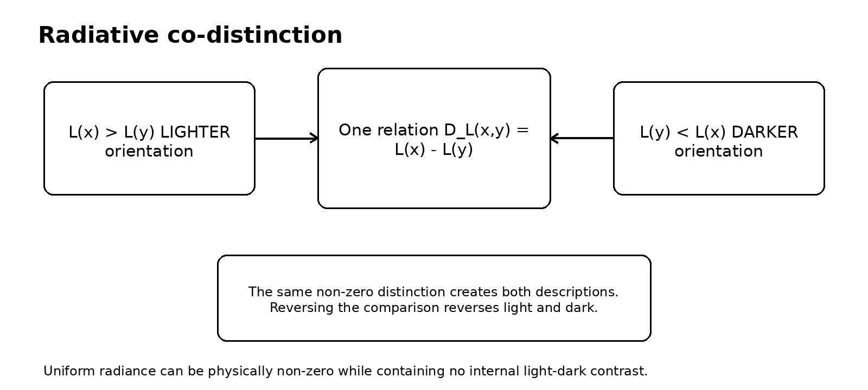
Figure 2. Light and darkness as the two orientations of one radiative distinction. The same non-zero relation creates both descriptions; reversing the comparison reverses them.

Part III · Selection

9. The Least-Cost Holonomy Principle
Assign the internal configuration space a positive metric g_ij(a). The geometric articulation cost of a loop and a time-parametrised effort cost are
C_ℓ[γ] = ∮_γ √(g_ij da^i da^j), C_e[a] = ∫₀^T ½ g_ij(a) ȧ^i ȧ^j dt.
The metric can encode unequal actuator effort, viscosity, inertia, smoothness penalties or field stiffness, so the motivating intuition becomes a statement about anisotropic distance in control space rather than a claim about counting muscles.
Let I[γ] denote the invariant accumulated by the cycle. The principle is a constrained optimisation,
minimise C[γ] subject to I[γ] = I₀, equivalently δ{ C[γ] − λ(I[γ] − I₀) } = 0.
Least-Cost Holonomy Principle. Among all admissible closed internal cycles that realise the required external invariant, the physical cycle is a stationary point of the system's actual control cost.
Under an isotropic length cost with a constant curvature coupling the solution is the isoperimetric one, and the circle is optimal because it encloses the most area per unit boundary. Under an anisotropic metric it is not, and the optimal loop is whatever shape the metric makes cheap. That is the honest form of the claim that circles appear: they appear when the cost is isotropic, and they do not otherwise.

10. The logical layer and the physical layer
The principle separates two constraints that are usually mixed.
Layer | Question | Mathematical role
Logical or task | What counts as the same successful result? | I[γ] = I₀ defines the equivalence class
Physical | Which realisation is admissible and least costly? | C[γ] and the equations of motion select within it

The separation is the useful feature of the framework, because it lets a system preserve abstract content while changing the physical path that instantiates it. It is also the structure that the next part tests, because I[γ] = I₀ is a quotient and quotients are safe only under conditions.

Part IV · Interrogation, and the Stability of the Class

11. The interrogative loop
A structure that emits is not yet interrogative. It becomes one when the emitted distinction passes through the environment and the structure's subsequent state depends on how that distinction was transformed. The minimal loop is
emit → interact → return → compare → respond.
Let the cyclic encoder be ψ = R e^{iθ} sourcing a directional intensity through an emission functional j[ψ,n] in the transport equation of Section 8. The environment enters through κ, the scattering kernel, boundary conditions and refractive structure. The returned radiation is summarised by u_r, F, D, ω or a comparison between emitted and received angular distributions. A minimal response is
∂_t ψ = −Γ δℱ/δψ* + χ ℛ[I;ψ] ψ + 𝒩_active[ψ,r],
with the first term relaxing under a passive free energy, the second letting environmental contrast change local growth, phase or motion, and the third carrying pumping and resource use.
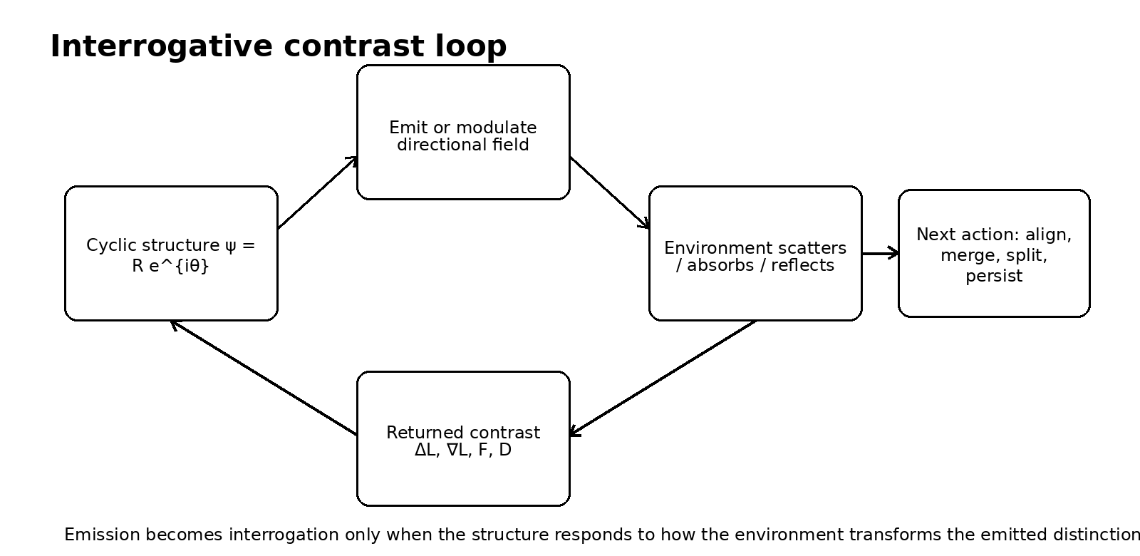
Figure 3. A cyclic encoder closes its dynamics through an interrogative contrast loop.

12. The holonomy class is not stable under interrogation
The draft proposed a combined objective
𝒥 = 𝒞[ψ] − λ ℋ[ψ] − η 𝒬[I,ψ],
with 𝒞 the physical cost, ℋ the required holonomy and 𝒬 the acquired directional distinction. Written this way the three terms look parallel. They are not, and the difference decides whether the principle of Section 9 is well posed once interrogation is switched on.
ℋ is constant on the class of loops realising the required invariant; that is what makes it a constraint. 𝒬 is not. The emission functional j[ψ,n] depends on the trajectory of ψ around the loop and not on the enclosed holonomy alone, so two loops with identical ℋ generically emit different angular distributions, receive different transformations from the environment, and return different 𝒬.
Proposition 12.1. Let Φ denote one pass of the interrogative loop. If 𝒬 separates two loops of equal holonomy, then the equivalence classes of the map γ ↦ ℋ[γ] are not stable under Φ, and no selection rule defined on holonomy alone reproduces the outcome of Φ for both loops.
Proof. Two loops in one class present the same input to any rule defined on the class, so a deterministic rule returns the same output for both. If their post-interrogation states differ, the single output is wrong for at least one. ∎
The consequence is not that the least-cost principle fails. It is that the invariant which gets constrained must carry the emission history and not only the enclosed area. On the refined class the principle is well posed again, and on the unrefined class it is well posed only for operations that see nothing but the holonomy.
The holonomy is what the loop delivers. It is not what the loop did, and interrogation asks the second question.
Proposition 12.1 is PROVED and elementary. Whether 𝒬 in fact separates loops of equal holonomy for a specified emission functional is a calculation that has not been done here, and it is the second open problem of this paper.

Part V · The Field Programme

13. From one cycle to a continuum
A continuum of local cyclic encoders is naturally described by a complex amplitude-phase field ψ = R e^{iθ}, with localised rotating regions connecting structurally to soliton and Q-ball models. A U(1) symmetry supplies a Noether current, and winding or charge density becomes a candidate measure of encoded structural content subject to strict symmetry and topology requirements.
Where the Shields field is potentiated, the background scalar φ is its potential, and φ carries the least-action closures at multiple scales, with localised density ρ_m = |ψ|² and field slope g_φ = −∇φ, and phase fronts propagating along the slope. That is the picture the draft's summary figure records, and it is retained here as a programme rather than as a result.
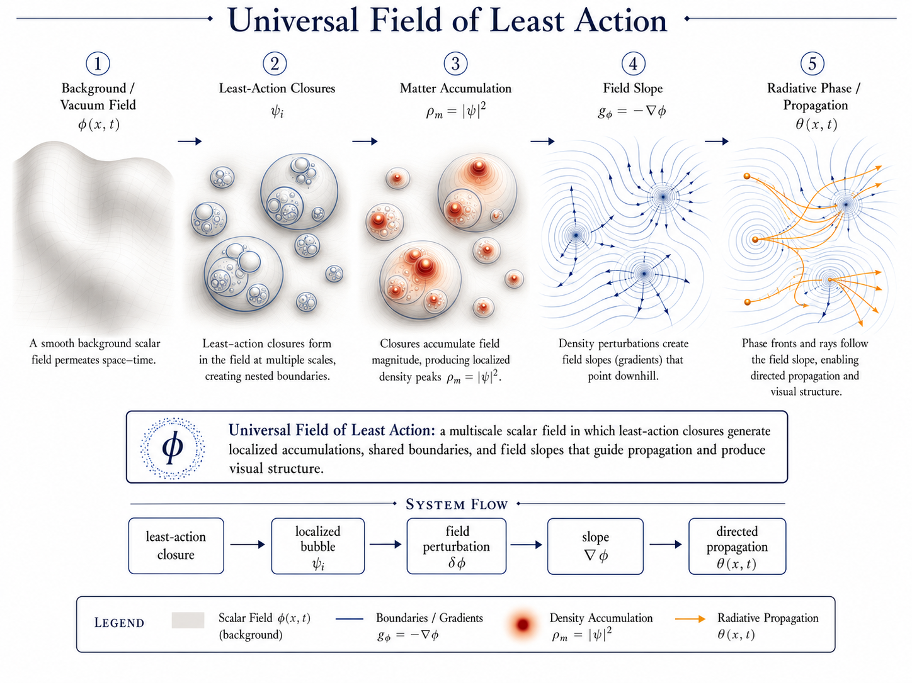
Figure 4. The programme, drawn in the potentiated case. Least-action closures in the potential φ generate localised accumulations, shared boundaries and field slopes that guide propagation. Where the Shields field is not potentiated, φ does not exist and only the closures and their differences do.

14. What replication does and does not follow from
One correction must be preserved because it is easy to lose. Least action alone does not imply self-reproduction. Conservative action principles yield persistence, oscillation and localisation. Repeated splitting or replication normally requires a driven, dissipative or unstable pattern-forming system, and the reaction-diffusion experiments that exhibit self-replicating spots supply the replication through non-equilibrium chemistry rather than through least action in isolation.
The action language therefore covers the passive core, and the active terms of Section 11 supply the open-system dynamics. Merging, splitting and replication are then distinct outcomes of one feedback architecture, with resource and inheritance conditions stated explicitly rather than assumed.

15. Status ledger
Statement | Status | Note
Closed internal loops produce net external holonomy | established | geometric mechanics
Loop output relates to enclosed curvature | established | exact in the Abelian case
Cost metrics optimise cyclic gaits | established | supports least-cost selection
Shields field is potentiated iff cocycle holds | proved here | Theorem 5.1
Obstruction is the class [ω] in H¹ | proved here | Corollary 5.2
Scattering obstructs a scalar radiance | proposed | Corollary 8.1, limiting cases only
Holonomy classes unstable under interrogation | proved here | Proposition 12.1
Replication follows from least action | not claimed | requires driven dynamics
The field is a known fundamental interaction | not claimed | no such identification is made

ABOVE THIS LINE: STANDARD GEOMETRY, COHOMOLOGY AND RADIATIVE TRANSFER
BELOW THIS LINE: THE AUTHOR'S OWN FRAMEWORK, OFFERED AS INTERPRETATION

Part VI · Extension · One Obstruction, Four Presentations

16. The line, and what is below it
Everything above uses standard differential geometry, standard cohomology and standard radiative transfer. Theorem 5.1 is a telescoping argument, Corollary 5.2 is de Rham, Proposition 12.1 is the pigeonhole applied to a deterministic map. A reader who rejects what follows keeps all of it.
What follows is the author's own framework, and the Corpus grades apply: PROVED, CONDITIONAL, PROPOSED, OPEN.

17. The same obstruction, four times
This paper is the fourth in a programme, and the reason for the extension is that the four have converged on one object without being designed to.
Paper | The closed thing | What fails to descend
The Depth of Traversal | the timelike curve, γ(T) = γ(0) | proper time; Δτ = ∮ of the metric form
Chiral Wave to PLA | the bulk Euler–Lagrange class | the boundary term; the topological class
This paper, Part II | the comparison triangle | the potential of the Shields field; [ω] ∈ H¹
This paper, Part I | the internal cycle, a(T) = a(0) | the output; ΔX = ∮A

In every row a quantity is closed on the base and fails to descend to it. The defect around a loop is a holonomy; the defect as a class is a cohomology class. Nothing is wrong with any of the base descriptions. Each is flat where the object it describes is not.
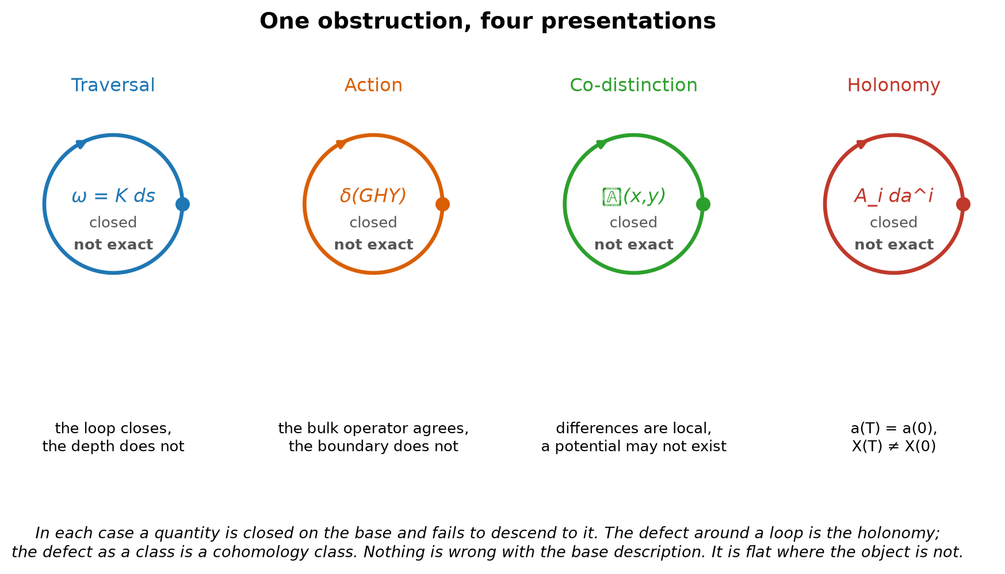
Figure 5. One obstruction in four presentations. In each case the base closes and the accumulated quantity does not.
Closed but not exact. That is the whole programme in three words, and it is standard mathematics rather than the author's.

18. What the framework adds to it
If the obstruction is standard, the question is what remains for the framework, and the answer is three things that the mathematics does not supply.
Which coordinate. The mathematics permits any fibre. The Register's T15 proves the order of accumulation is single, because two independent orders would be two records and therefore two systems, so the lift adjoins one coordinate rather than an arbitrary number. That is the same result used in the traversal papers and in the logical-action paper, and it is one identification serving three.
Which direction. A general connection has holonomy of either sign. The traversal condition K ≥ 0 makes it sign-definite, and a sign-definite holonomy is an arrow rather than a phase. The Shields field of Part Two is the case where the sign is not fixed, which is why light and dark are two orientations of one relation and neither is prior. The two cases are the same geometry with and without an arrow, and the framework says which physical situations get one.
Which loop. The mathematics says the holonomy is what it is. Section 9 adds a selection principle: among the loops realising it, the physical one is stationary in cost. That is the piece the earlier papers of the programme did not have, and it is this paper's contribution to them.
The identification of the traversal lift, the logical-action refinement and the co-distinction potential as one obstruction is PROPOSED. It is supported by the four constructions having the same form and by three of them being derived independently before the fourth was written. The rank-one claim is CONDITIONAL on T15 as in the companion papers, and it is the same single identification, not a fourth one.

19. What is owed
Two calculations and one identification. The cohomology class of a named scattering kernel, which would move Corollary 8.1 from proposed to settled. Whether 𝒬 separates loops of equal holonomy for a specified emission functional, which would settle Proposition 12.1's premise. And the identification named in the companion papers, that the retained order of these constructions is the Register's single order of accumulation, which this paper inherits and does not add to.
What would end it. A scattering medium in which differences do compose, contradicting Corollary 8.1. An interrogative architecture whose response depends only on holonomy, making Proposition 12.1 vacuous. Or a demonstration that the four presentations of Section 17 are related only by analogy, which would be shown by exhibiting one of them in which the defect is not a cohomology class.

20. Closing
The earlier draft named a field and described how it behaves. The field is an antisymmetric two-point function, its two orientations are one relation, and whether it can be replaced by a brightness is a cocycle question with a proof either way. Where a medium scatters, it cannot be, and the failure is not a loss of contrast but the absence of the quantity that contrast was supposed to be a difference of.
That result stands on its own. It also happens to be the fourth time this programme has met the same structure: something closes, something else does not descend, and the gap between them is where the physics was.
A difference between two places becomes a quantity at a place only when differences compose. Where they do not, the difference is all there is, and it is not less real for having no least action to be least.

References
1. Marsden, J. E. and Ratiu, T. S. (1999). Introduction to Mechanics and Symmetry, 2nd ed. Springer.
2. Shapere, A. and Wilczek, F. (1989). “Geometry of Self-Propulsion at Low Reynolds Number.” Journal of Fluid Mechanics 198, 557–585.
3. Berry, M. V. (1984). “Quantal Phase Factors Accompanying Adiabatic Changes.” Proceedings of the Royal Society A 392, 45–57.
4. Bott, R. and Tu, L. W. (1982). Differential Forms in Algebraic Topology. Springer. De Rham cohomology and the exactness obstruction.
5. Chandrasekhar, S. (1960). Radiative Transfer. Dover Publications.
6. Mihalas, D. and Weibel-Mihalas, B. (1984). Foundations of Radiation Hydrodynamics. Oxford University Press.
7. Pearson, J. E. (1993). “Complex Patterns in a Simple System.” Science 261, 189–192.
8. Lee, K.-J., McCormick, W. D., Pearson, J. E. and Swinney, H. L. (1994). “Experimental Observation of Self-Replicating Spots in a Reaction–Diffusion System.” Nature 369, 215–218.
9. Coleman, S. (1985). “Q-Balls.” Nuclear Physics B 262, 263–283.
10. Shields, J. (2026). “The Depth of Traversal.” Working paper. Cited in Part Six.
11. Shields, J. (2026). “From Chiral Wave Evolution to the Principle of Logical Action.” Working paper. Cited in Part Six.
12. Shields, J. (2026). Unified Mechanics, Corpus Edition, Fifth Printing. Formal Register, T15. Cited in Part Six.

Part VII · Computational Maps and General-Relativistic Coupling
This supplement consolidates the Universal Field of Least Action visual system, the Solar System field atlas, the exoplanet ensemble experiment, the three-vector reconstruction, the identifiability result for μ = GM, and the proposed coupling to general relativity through an effective stress-energy tensor. It is written as one continuous research programme while preserving the status distinctions of the formal paper: established mathematics, implemented visualisation, proposed reinterpretation, and open physical identification.
Central architecture
Least-action closures and relational distinctions define the candidate matter sector; a covariant matter action converts that sector into an effective stress-energy tensor; general relativity converts the tensor into spacetime geometry; and the interactive maps expose the resulting local and multiscale structure.

21. Supplement contents
Section | Subject | Output
22 | Universal Field of Least Action | Canonical definition, bubbles, scalar maps and visual layers
23 | Solar System Field Atlas | Interactive orbital and field reconstruction
24 | Local three-vector frame | Information recovered from r, v and gφ
25 | Exoplanet Ensemble Lab | Large-sample field-law recovery and diagnostics
26 | What the data identify | Why orbits yield μ = GM rather than G alone
27 | General relativity as toolkit | Source-to-geometry architecture
28 | Proposed stress-energy tensor | Local action, tensor components and relational sector
29 | Weak-field bridge | Connection to Newtonian potential, mass and field maps
30 | Tests and falsification | Calculations needed to move from programme to theory
31 | Software deliverables | Interactive files and implementation map
32 | Status ledger | Established, implemented, proposed and open claims

22. The Universal Field of Least Action

22.1 Canonical definition
Universal Field of Least Action
A multiscale field programme in which least-action closures generate localised accumulations, shared boundaries and field slopes; cyclic phase carries internal state; pairwise co-distinction records relations that may or may not reduce to a scalar potential; and the resulting structure is rendered as an interactive visual map.

The phrase “field of least action” is used for the complete programme, not as a replacement for the precisely defined Shields field of distinct actions. The formal paper distinguishes three objects. The computational programme uses all three and makes their different roles visible.
Object | Mathematical role | Visual role
φ(x,t) | Real scalar potential when the co-distinction is exact | Continuous field value, level sets, slopes and potential basins
ψ(x,t) = R e^{iθ} | Complex amplitude-phase field carrying local cyclic closures | Bubbles, closure amplitude, internal phase and localised density ρm = |ψ|²
𝒟(x,y) | Antisymmetric two-point co-distinction | Pairwise light/dark, action/action or source/source comparison; loop residue when no scalar potential exists
Aμ or ω | Connection/one-form representing transport and holonomy | Path arrows, accumulated phase, curvature and non-exact loop structure
r(x,t), active fields | Resource, pumping or driven open-system degrees of freedom | Growth, fission, merging and replication controls when the system is non-equilibrium

22.2 Bubbles as the multiscale visual primitive
A bubble is the smallest locally closed region through which a field distinction is preserved against its surroundings. It is not merely a drawn circle: it packages an interior, a boundary, a scalar amplitude, a phase, a scale and a location in the hierarchy.
ℬᵢ = (Ωᵢ, ∂Ωᵢ, aᵢ, sᵢ, θᵢ, ℓᵢ).
The same closure rule is reused across scale. A distant view compresses a collection of sub-closures into one effective closure; a close view resolves that closure into a field of smaller bubbles. Fractality therefore means recurrence of the generative operation rather than exact visual self-similarity.
{ℬᵢ^(ℓ)} ⟶ ℬⱼ^(ℓ+1), closure ⟶ boundary ⟶ relation ⟶ higher closure.
In the potentiated sector, a smooth scalar map can be reconstructed from bubble profiles:
φ(x,t) = φ₀ + Σᵢ aᵢ(t) K( ||x − Xᵢ(t)|| / sᵢ(t) ).
Level sets φ = τ expose boundaries; −∇φ exposes field slopes; overlap integrals expose relational proximity; and the complex phase θᵢ supplies internal cyclic orientation. The smooth map is therefore a rendering of the bubble hierarchy, not the assumed primitive.

Figure 6. Canonical visual flow of the Universal Field of Least Action: background, least-action closures, accumulated density, field slope and directed propagation.

22.3 The first boundary
The first-boundary interpretation reverses the usual order of presentation. Rather than assuming a configuration space and imposed boundary conditions before varying an action, it treats the first stable least-cost closure as the event that generates a locally distinguishable region.
least action ⟶ first closure ⟶ first boundary ⟶ relational boundaries ⟶ field.
For a candidate region Ω enclosing a non-zero invariant Q[Ω] = Q₀, define a closure cost 𝒜[Ω]. The first closure is the minimiser in the admissible class, and its boundary is the first generated boundary:
Ω★ = arg min_{Ω:Q=Q₀} 𝒜[Ω], B₀ = ∂Ω★.
Under isotropic boundary cost and fixed volume, the sphere is the least-area enclosure. Anisotropic field stiffness, flux, neighbouring closures or phase structure deform that solution. Shared internal boundaries can cancel from the external sum while remaining active as exchange surfaces inside the total configuration.
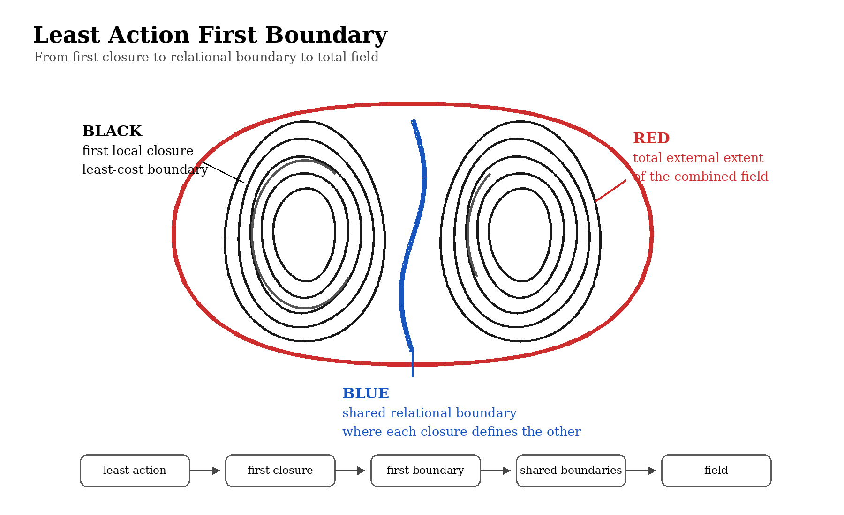
Figure 7. First boundary from least action: local closures create shared relational boundaries and a total field extent.

23. Solar System Field Atlas
The Solar System site is an interactive field atlas built from approximate JPL Keplerian elements and rates. For a chosen date it calculates heliocentric positions, renders orbital closures and overlays the candidate scalar field, bubble hierarchy, shared boundaries, field-slope arrows, radiative paths and status-labelled diagnostics. The JPL approximation is suitable for visualisation and lower-accuracy applications; it is not a replacement for a high-precision integrated ephemeris such as Horizons.
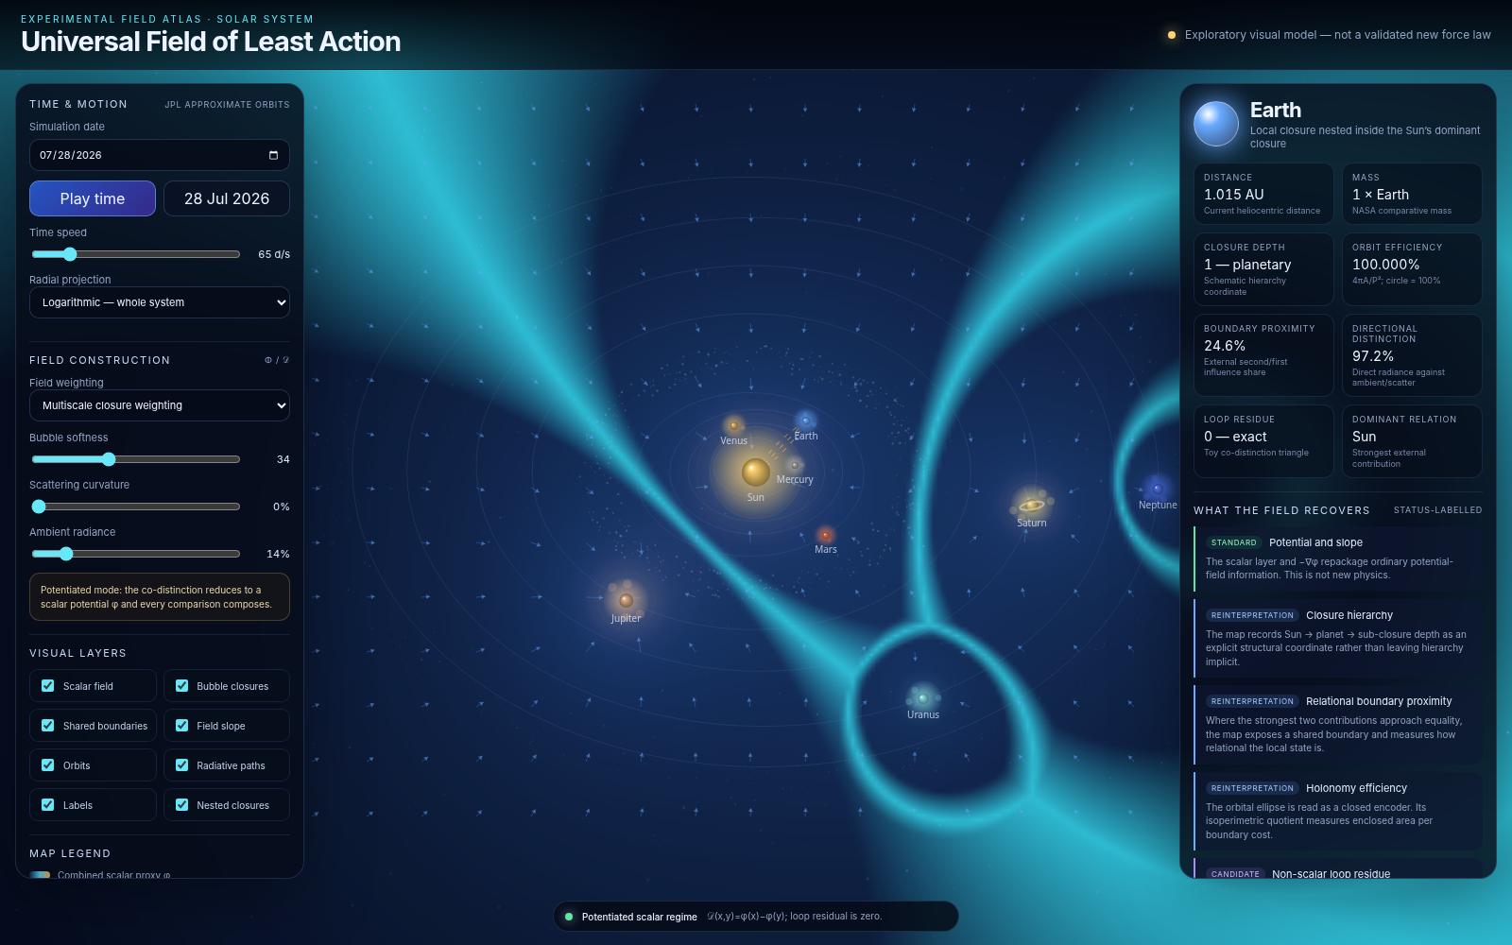
Figure 8. Solar System Field Atlas. The centre map combines approximate planetary orbits with scalar-field, bubble-boundary and gradient layers; the side panels expose the model assumptions and recovered diagnostics.

23.1 What the Solar System map computes
Layer | Computed object | Interpretive value
Orbital state | Approximate r(t) and orbit from a,e,I,L,ϖ,Ω | Standard celestial mechanics; date-dependent angular placement
Scalar field | φ(x) from selected source weighting and bubble kernels | Potential-like landscape used for visual comparison
Gradient | gφ = −∇φ | Local direction of steepest field descent
Bubble closures | Nested level sets and source-centred closures | Explicit multiscale hierarchy rather than an implicit source list
Shared boundaries | Locations where leading local contributions approach equality | Relational interfaces and dominance transitions
Radiative paths | Paths drawn through the selected landscape | Visual interrogation/propagation layer; not yet a GR null-geodesic solver
Loop residue | Triangle sum of pairwise distinctions | Toy exactness test: zero in the potentiated mode, non-zero only when path dependence is introduced

The map deliberately labels outputs by status. Ordinary orbital mechanics, potential gradients and vector decomposition are standard. Closure depth, boundary proximity and holonomy efficiency are reinterpretations of the same data. A non-scalar loop residue is a candidate diagnostic and must be obtained from a specified physical transport law before it can be called a Solar System effect.

24. The local three-vector frame
At each body, the visualiser organises the local state around three vectors: position r, retained motion v, and field-selected acceleration gφ. This does not create new independent data. It creates a complete local relational frame from which many quantities that are normally introduced in separate formalisms become direct projections.
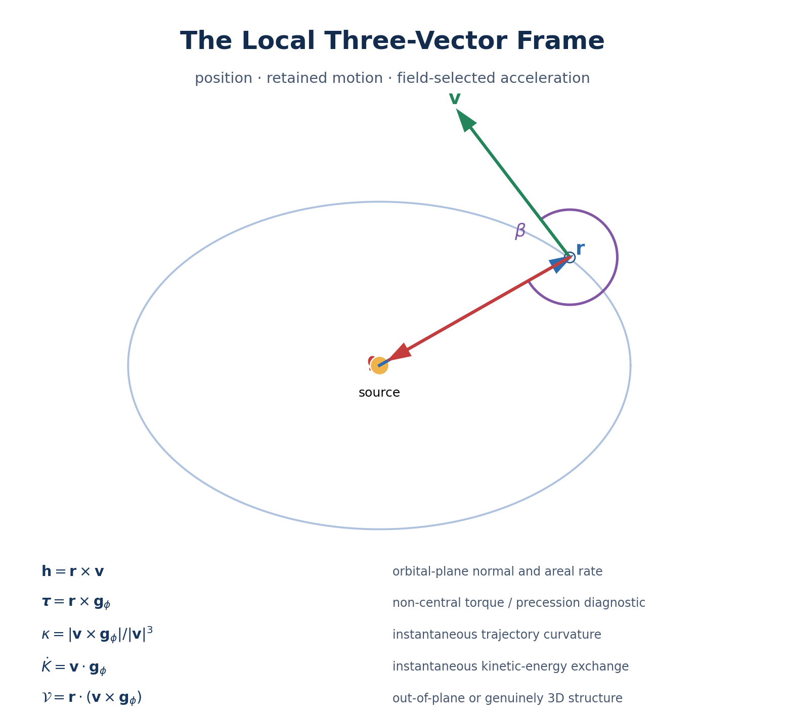
Figure 9. The three-vector frame: position, retained motion and field-selected acceleration, with the principal scalar, vector and triple-product diagnostics.
Operation | Recovered quantity | Physical reading
r · v | Radial motion | Whether the object is moving inward, outward or instantaneously tangentially
v · gφ | Power per unit mass | Whether the field is increasing speed, decreasing speed or only turning the velocity
r × v = h | Specific angular momentum | Orbital-plane normal, handedness and areal sweep rate dA/dt = |h|/2
r × gφ = τ | Torque per unit mass | Non-central forcing, orbital-plane evolution or modelling residual
|v × gφ| / |v|³ | Trajectory curvature κ | Instantaneous bending of the path
r · (v × gφ) | Oriented 3-volume | Whether the local dynamics contain genuinely out-of-plane structure
∂ᵢ∂ⱼφ | Tidal/Hessian tensor | Principal stretching, compression, saddle and stability directions
∇ · gφ and ∇ × gφ | Source and rotational diagnostics | Potential-sector consistency and non-potential structure

For a near-circular orbit, v is approximately tangent while gφ is approximately radial and inward, so their angle is near 90 degrees. Ellipticity changes that angle through the orbit. The closed trajectory is therefore read as the maintained relation between accumulated direction and field-directed turning.

25. Exoplanet Ensemble Lab
The second site scales the same analysis beyond the Solar System. It queries the NASA Exoplanet Archive Planetary Systems table through TAP when available and selects rows containing an orbital period P, semi-major axis a and host-star mass M★. The Planetary Systems table is preferred for a consistency experiment because each row is a self-contained published planet-plus-star solution for one reference; the Composite table is more complete but can combine parameters from different references.
μᵢ = 4π² aᵢ³ / Pᵢ², ḡᵢ = 4π² aᵢ / Pᵢ².
The ensemble then fits the mass and radial powers freely rather than hard-coding the Newtonian exponents:
log ḡ = c + α log M★ + n log a.
The conventional central inverse-square result corresponds to α = +1 and n = −2. The site also reconstructs a common orbital phase for each selected system and calculates r, v, g, angular momentum, energy, curvature, motion-field angle, torque residual and the source-scaled gravitational parameter.
Stage | Inputs | Outputs
Catalogue selection | P, a and M★ | Self-contained published solutions with a usable orbital scale
Field reconstruction | P and a | μ = 4π²a³/P² and mean field scale ḡ = 4π²a/P²
Free law fit | M★, a and ḡ | Mass exponent α, radial exponent n and residuals
Closure diagnostics | Common phase and eccentricity | r, v, g, h, κ, τ, energy and motion–field angle

Interpretive boundary
The ensemble is designed to test compression and consistency. It can recover an empirical field law and its residual structure, but it cannot turn catalogue masses into an independent derivation of G unless the source scale is fixed without gravitational circularity.

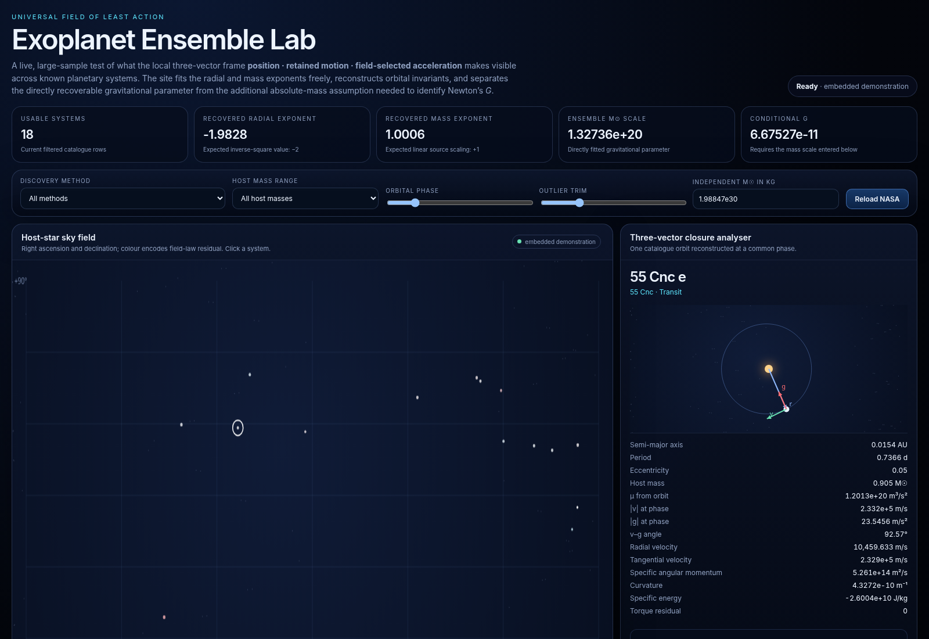
Figure 10. Exoplanet Ensemble Lab interface in its embedded offline demonstration mode. The live version attempts a current NASA TAP query; the embedded sample is only a rendering and calculation sanity check.
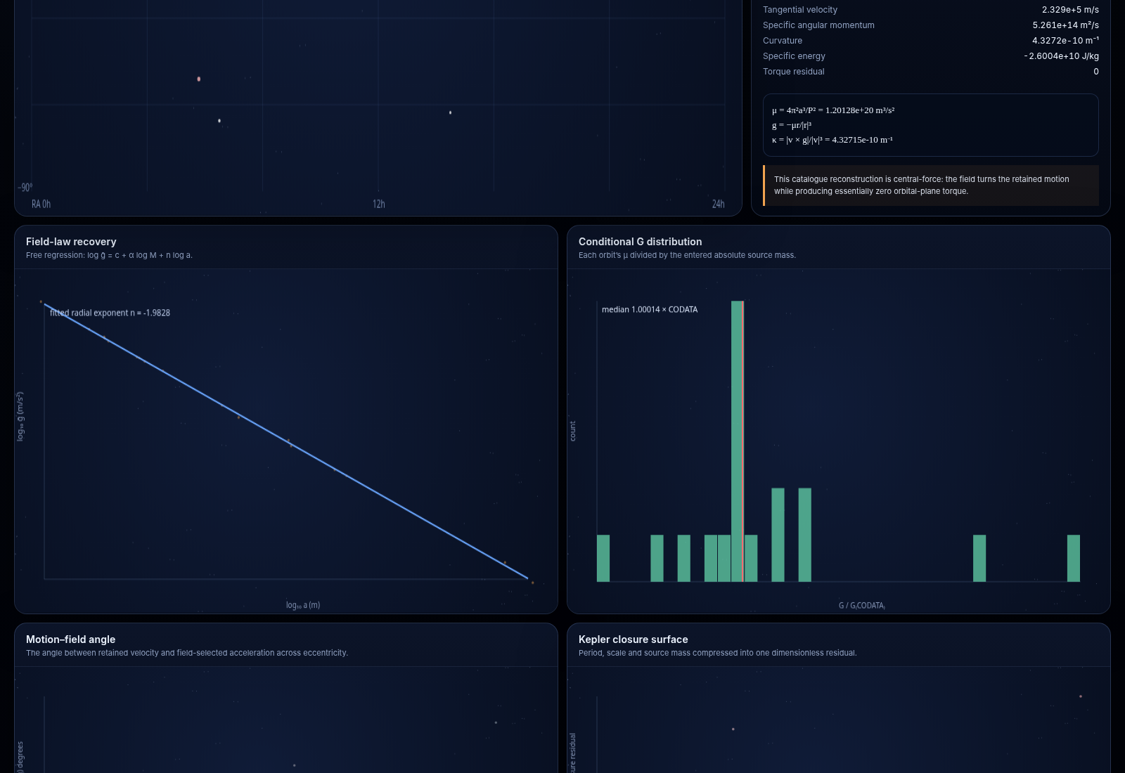
Figure 11. Ensemble diagnostics: freely fitted radial law, conditional-G distribution, motion-field angle and closure residual surfaces. The screenshot values arise from the embedded demonstration sample, not an independent measurement.

25.1 What the ensemble can recover
Result | Directly determined? | Caveat
Radial exponent n | Yes, from the selected catalogue variables | Selection effects, correlated published parameters and outlier treatment must be audited
Mass exponent α | Yes, conditional on catalogue stellar masses | The masses themselves are model-dependent and are not independent absolute standards
μ = GM for each system | Yes, from P and a | Some published a values may already be derived using Keplerian assumptions
Three-vector orbital diagnostics | Yes, within the reconstructed two-body model | They reorganise known orbit information rather than create new observations
Conditional G | Only after an independent mass scale is supplied | Dividing μ by a gravity-derived mass is circular
Non-scalar co-distinction residue | Not from the catalogue alone | Requires path-dependent transport or another specified relational measurement

Embedded demonstration status
The offline sample displayed in Figure 10 returns n ≈ −1.9828, α ≈ 1.0006 and conditional G ≈ 6.67527 × 10⁻¹¹ m³ kg⁻¹ s⁻². These values validate the interface pipeline only. They are not an independent measurement because the sample and its stellar masses come from standard orbital and stellar modelling.

26. What orbital data identify: μ, not G alone
The large-sample experiment isolates a genuine identifiability boundary. Gravity enters the two-body acceleration through the product μ = GM:
g = − μ r / |r|³ = − GM r / |r|³.
The transformation G → λG and M → M/λ leaves every orbit unchanged. Increasing the number of planetary systems improves the estimate of the common law and its scatter, but it does not separate the universal coupling from the absolute source normalisation. Orbits therefore identify a geometric source strength, not kilograms by themselves.
m_geom = GM/c² = μ/c², r_s = 2GM/c².
This makes the geometrised source the natural intermediate target. A field theory can predict μ, GM/c² or the full stress-energy tensor without first expressing its raw amplitude in kilograms. Kilograms enter only when one chooses SI units or when one tries to derive the numerical SI value of G.
Programme mode | Imported quantity | Field must determine | What is achieved
GR as toolkit | Measured G and the Einstein equation | A covariant source Tμν from φ, ψ, 𝒟 and any active fields | A gravitational model whose source is defined by the new field sector
Geometric prediction | G may remain implicit in geometrised units | The metric source scale GM/c² or an equivalent invariant | Orbits, lensing, redshift and geometry without internal kilograms
Derivation of G | Only non-gravitational standards such as c and possibly ℏ | Both an absolute inertial-energy scale and the gravitational source strength | A non-circular prediction of the SI coupling G

27. General relativity as the toolkit
The clean architecture is not to replace general relativity at the outset. The Universal Field of Least Action supplies a matter/source sector. General relativity supplies the covariant conversion from that source to spacetime geometry.
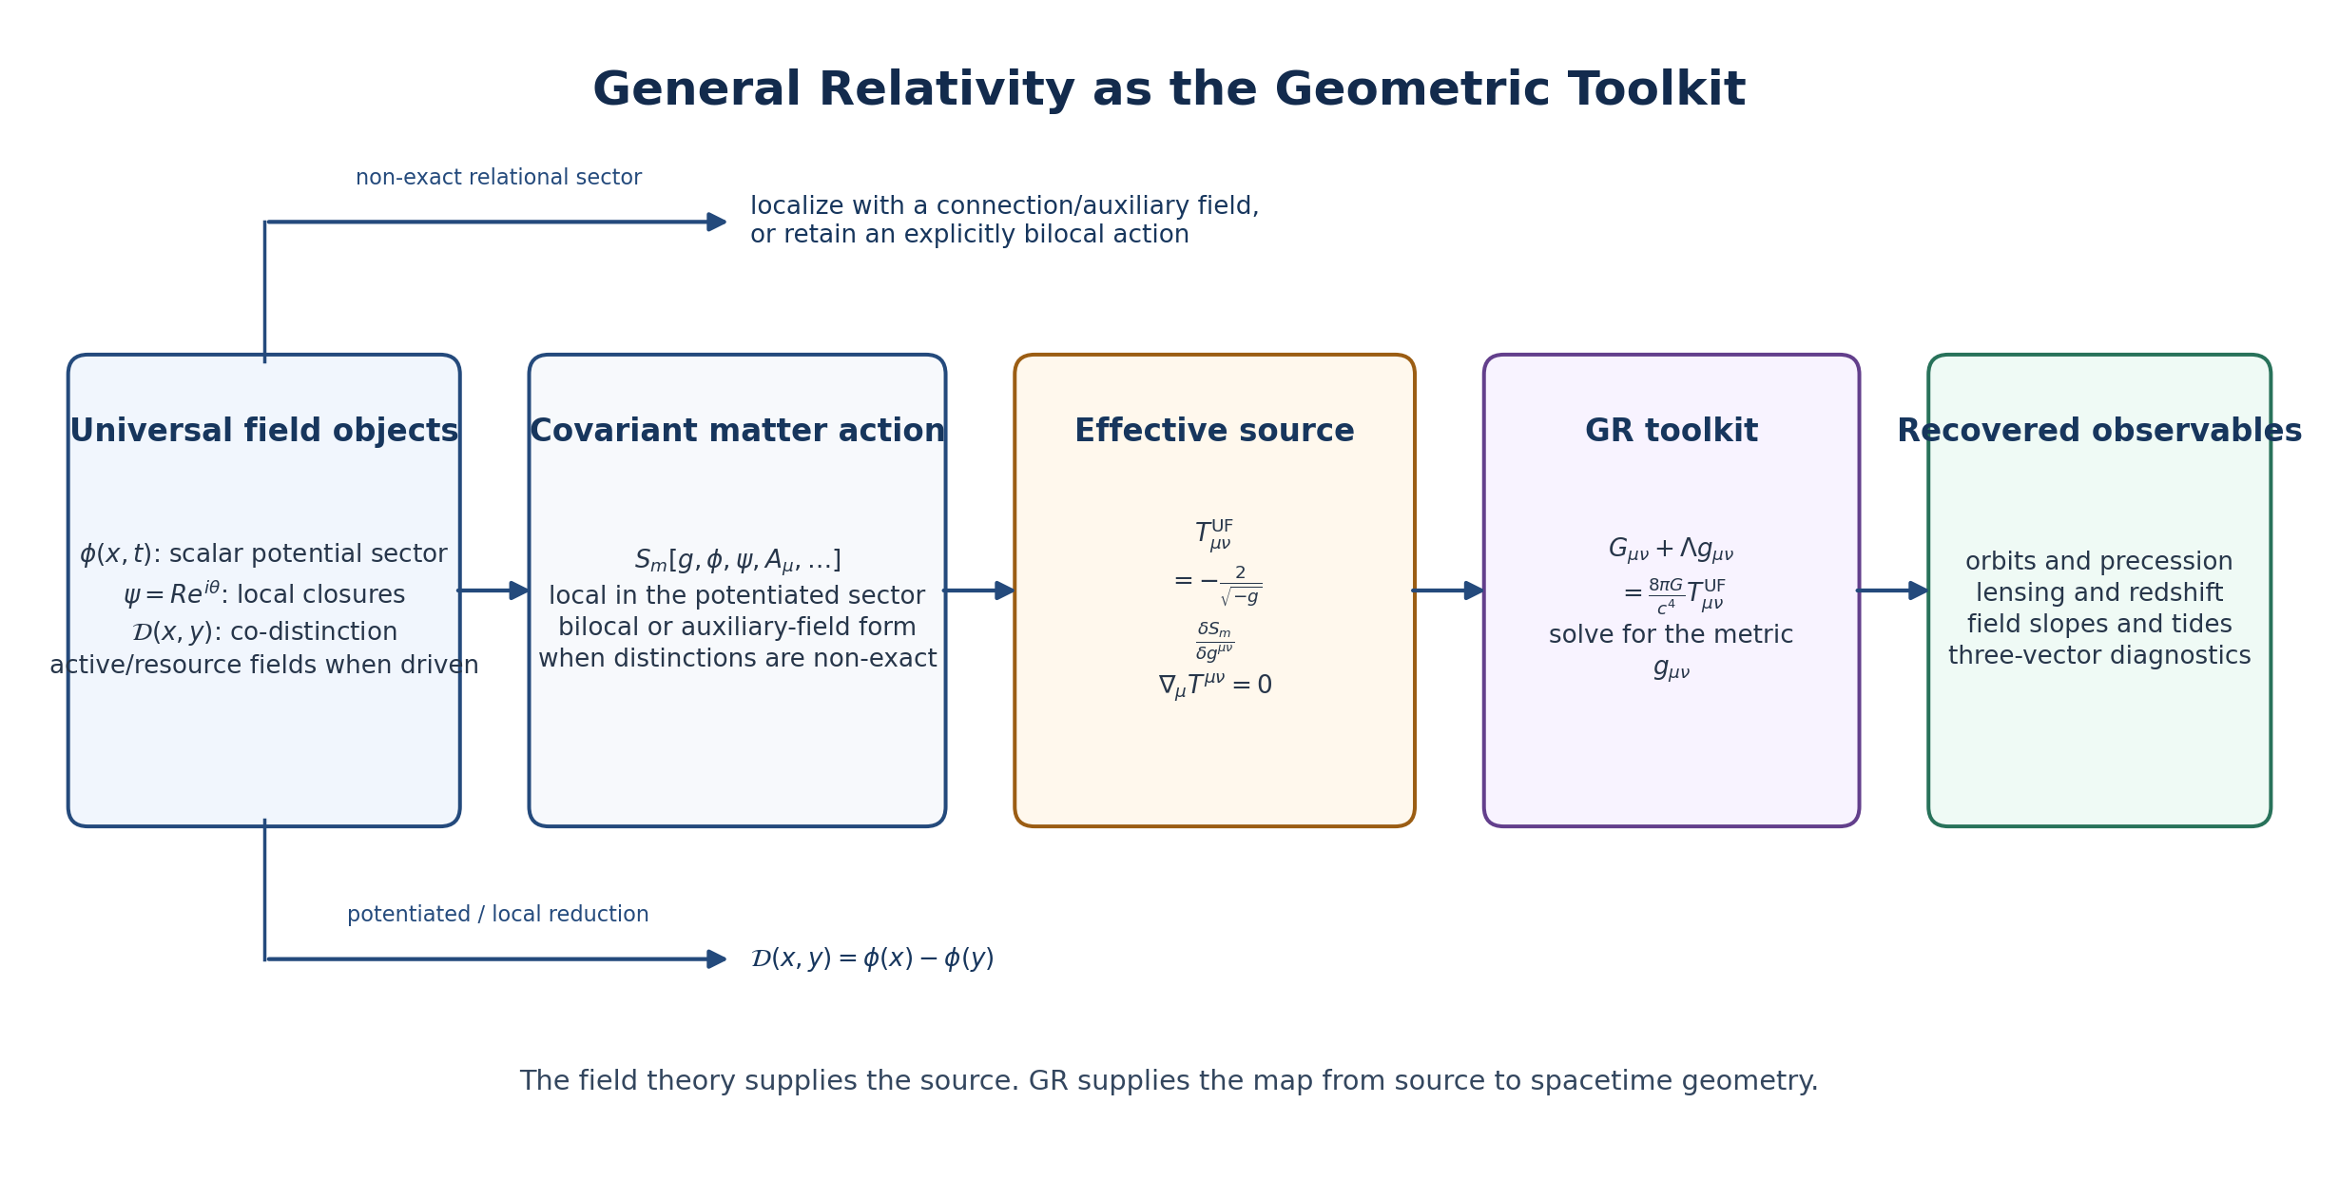
Figure 12. Source-to-geometry architecture. The field programme defines a covariant matter action and stress-energy tensor; general relativity maps that source into a metric and observable motion.
Gμν + Λ gμν = (8πG/c⁴) Tμν^UF.
This division of labour is exact in intent: the left-hand side is the Einstein geometry; the right-hand side is where the proposed field objects must earn their physical interpretation. The central task is therefore to formulate a diffeomorphism-invariant matter action and vary it with respect to the metric.
Tμν^UF = − (2/√−g) δS_UF / δg^{μν}.
Diffeomorphism invariance then requires covariant conservation on solutions:
∇μ T^{μν}_UF = 0.
For driven, dissipative or interrogative dynamics, individual sectors may exchange energy-momentum. In that case the passive and active tensors need not be separately conserved, but the total must be: ∇μT_passive^{μν}=Q^ν, ∇μT_active^{μν}=−Q^ν.

28. Candidate covariant action and stress-energy tensor

28.1 Potentiated local sector
Adopt metric signature (−,+,+,+). In the sector where the co-distinction is exact and admits a scalar potential φ, a minimal local action can be written as follows. This is a candidate model, not a derivation from the present axioms:
S = (c⁴/16πG) ∫ d⁴x √−g (R − 2Λ) + ∫ d⁴x √−g 𝓛_UF.
𝓛_UF = −½ K(φ) ∇μφ ∇^μφ − V(φ) − (Dμψ)* D^μψ − U(|ψ|,φ) − ¼ Z(φ) FμνF^μν + 𝓛_active.
Here K controls scalar stiffness, V controls the background and closure-supporting potential, ψ = R e^{iθ} carries local cyclic closures, Dμ = ∇μ − iqAμ is an optional gauge-covariant derivative, U couples closure amplitude to the background, Z permits a field-dependent radiative coupling, and 𝓛_active represents additional degrees of freedom needed for driven growth, fission or replication.

28.2 Tensor components
Varying the local passive terms gives a sum of standard tensor structures. With the conventions above:
Tμν^(φ) = K(φ) ∇μφ ∇νφ − gμν [ ½K(φ)(∇φ)² + V(φ) ].
Tμν^(ψ) = (Dμψ)*Dνψ + (Dνψ)*Dμψ − gμν [ (Dαψ)*D^αψ + U(|ψ|,φ) ].
Tμν^(rad) = Z(φ) [ Fμα Fν^ α − ¼ gμν FαβF^αβ ].
Tμν^UF = Tμν^(φ) + Tμν^(ψ) + Tμν^(rad) + Tμν^(active) + Tμν^(rel).
The interaction potential U contributes through the metric term in Tμν^(ψ). Additional derivative couplings would add corresponding terms. The tensor is not chosen separately from the action: the action fixes both the equations of motion and the source supplied to Einstein geometry.

28.3 Where the bubble mass comes from
A bubble does not need an amplitude labelled in kilograms. Once the action has physical dimensions, the configuration carries an energy density through T₀₀. Its effective inertial/gravitational source is then the integral of that energy density, including amplitude, gradients, phase motion, potential energy, gauge energy and active resources.
ρ_eff = T₀₀^UF / c², M_eff = ∫Σ ρ_eff √γ d³x.
For a static weak-field configuration, a schematic density is:
ρ_eff ≈ [ ½K|∇φ|² + V(φ) + |D₀ψ|²/c² + |Dᵢψ|² + U + ρ_rad c² + ρ_active c² ] / c².
Key correction
The amplitude normalisation and the Lagrangian together establish energy units. The theory does not need to declare that ψ itself is measured in kilograms. It must specify an action whose finite-energy closures possess a calculable T₀₀.

28.4 The non-exact co-distinction sector
The Shields field 𝒟(x,y) is bilocal. Standard general relativity is sourced locally, so an unpotentiated co-distinction cannot simply be inserted into Tμν as though it were a scalar at x. Two mathematically distinct routes are available.
Route | Form | Requirement
Auxiliary/local connection | Represent local transport by a one-form Bμ or connection ω with curvature Hμν = ∇μBν − ∇νBμ; build a covariant local action from Hμν and its couplings | Show that the chosen connection faithfully represents the measured co-distinction and fixes its dynamics
Explicit bilocal action | S_D = ½ ∫∫ d⁴x d⁴y √−g(x)√−g(y) W(x,y) 𝒟(x,y)² | Use a diffeomorphism-covariant kernel W and accept a nonlocal functional derivative for the effective source

The local-connection route is usually easier to couple to GR, but it is an additional model choice. The bilocal route keeps the relational primitive explicit but creates a genuinely nonlocal gravitational source. In either case, the resulting tensor must satisfy the appropriate conservation identity.

29. Weak-field bridge to the visual maps
To connect the interactive scalar slope to gravity, expand the metric about weak, slowly varying fields:
g₀₀ ≈ −(1 + 2Φ_N/c²), gᵢⱼ ≈ (1 − 2Ψ/c²) δᵢⱼ.
The 00 component of the Einstein equation then reduces, under the usual non-relativistic assumptions, to a Poisson equation for the Newtonian potential:
∇²Φ_N = 4πG ρ_eff, g_N = −∇Φ_N.
This is the exact bridge the visual programme must establish. The rendered φ is not automatically the Newtonian potential. A successful model must derive a calibration Φ_N = f(φ,ψ,𝒟) or show that φ itself obeys the correct weak-field equation with the correct source and dimensions.
μ_eff = G M_eff = G ∫Σ (T₀₀^UF/c²) √γ d³x.
Once this bridge is fixed, the three-vector maps become predictions rather than reorganisations: r and v come from observation, while g_UF comes from the solved field equations. The decisive residual is then g_observed − g_UF, tested across Solar System ephemerides, binary systems, exoplanets, lensing and larger-scale structures.

29.1 Light propagation
In a relativistic completion, light follows null geodesics of gμν unless the radiative sector contains additional couplings such as Z(φ)F². The present drawn radiative paths are therefore conceptual. They must eventually be replaced by null-geodesic integration through the solved metric, with any non-minimal optical coupling tested against equivalence-principle and frequency-dependence constraints.

30. Research and falsification programme
1. Choose a definite local action for φ and ψ, including dimensions, couplings and a closure-supporting potential U.
2. Find finite-energy localised solutions and determine whether the least-cost boundary is spherical under isotropic conditions and how it deforms under phase, rotation and neighbouring closures.
3. Compute Tμν exactly from the action and verify ∇μT^{μν}=0 on the equations of motion.
4. Derive the weak-field limit and show whether Φ_N satisfies ∇²Φ_N = 4πGρ_eff without inserting the desired result by hand.
5. Solve the isolated-source metric and compare its exterior with Schwarzschild; calculate the post-Newtonian parameters, perihelion precession, Shapiro delay, redshift and lensing.
6. Replace the Solar System visual proxy with JPL/Horizons state vectors and compare predicted field acceleration against ephemeris residuals.
7. Run the exoplanet law fit on a documented frozen NASA Archive query, propagate uncertainties and audit dependence among period, semi-major axis and stellar-mass estimates.
8. Determine whether the model predicts μ from closure structure independently of orbital data; only then can the ensemble test become predictive rather than reconstructive.
9. For the co-distinction sector, compute a named scattering kernel and evaluate the cocycle/holonomy obstruction rather than introducing an arbitrary curvature control.
10. Treat merging, fission and replication only in an explicit open-system model with resource flow, instability and inheritance; do not infer them from stationary action alone.
What would falsify the gravitational programme
Failure to obtain a conserved tensor; failure of the weak-field limit; disagreement with inverse-square behaviour, post-Newtonian tests or lensing; composition-dependent free fall; frequency-dependent vacuum light propagation beyond limits; or a claimed relational residue that disappears when calculated from a specified transport law.

31. Software deliverables and implementation map
File | Purpose | Core controls / outputs
universal-field-solar-system.html | Interactive Solar System Field Atlas | Date, time animation, radial projection, source weighting, bubble softness, ambient radiance, scattering-curvature demonstration, field layers, selected-planet diagnostics
universal-field-solar-system.zip | Packaged Solar System site | Portable archive of the standalone HTML deliverable
universal-field-exoplanet-lab.html | Live/embedded exoplanet ensemble analysis | NASA TAP query, filters, free exponent regression, sky residual map, three-vector inspector, conditional-G bridge
universal-field-exoplanet-lab.zip | Packaged exoplanet site | Portable site package and notes
Universal Field figures | Paper visual architecture | First boundary, co-distinction, interrogative loop, scalar map and GR coupling diagrams

31.1 Recommended next software revision
• Add explicit velocity vectors and numerical position-motion-field angles to the Solar System atlas.
• Add a tensor layer displaying the Hessian eigenvectors and eigenvalues of the scalar potential.
• Replace the toy scattering-curvature control with a named radiative-transfer kernel and computed loop residue.
• Add a GR mode that solves or imports a metric and traces null geodesics rather than drawing proxy light paths.
• Freeze and export the exact NASA TAP query, retrieval date, row count and uncertainty filters for reproducible ensemble analyses.
• Add a source-model panel that evaluates M_eff = ∫T₀₀/c² d³x once a definite field Lagrangian is selected.

32. Consolidated status ledger
Claim or object | Status | Meaning
Closed internal loops can produce external holonomy | Established | Standard geometric mechanics
Co-distinction is exact iff the cocycle condition holds | Proved in the formal paper | Standard cochain/cohomology result applied to the named object
Three-vector frame recovers orbital diagnostics | Implemented / standard | A compact visual reorganisation of state-vector mechanics
Solar System scalar and bubble map | Implemented visual model | Exploratory rendering; not a validated new force law
Exoplanet free power-law regression | Implemented experiment | Tests catalogue scaling but inherits catalogue modelling and selection
Orbits identify μ = GM rather than G and M separately | Established identifiability result | No sample size removes the product degeneracy without an independent scale
GR can serve as the toolkit | Consistent programme choice | Requires a covariant source tensor from the field sector
Candidate local action and Tμν in Section 28 | Proposed | A minimal technically coherent starting model, not yet derived from Unified Mechanics
Unpotentiated 𝒟 couples through auxiliary or bilocal dynamics | Open modelling choice | Must be specified and tested
Bubble energy gives an absolute source | Conditional | True only after action normalisation and finite-energy solutions are fixed
Numerical G is derived | Not achieved | Requires an independently fixed non-gravitational energy/mass normalisation or deeper coupling derivation
Merging, splitting and replication | Proposed active dynamics | Need driven resources, instabilities and inheritance

33. Closing synthesis
The computational work has clarified the programme rather than merely decorated it. The Solar System map demonstrates that position, retained motion and field-selected acceleration form a compact local grammar from which angular momentum, torque, curvature, energy exchange, tidal structure and closure relations become simultaneously visible. The exoplanet site shows how the same grammar scales to an ensemble and exposes the exact boundary between the recoverable gravitational parameter μ and the additional absolute scale required for G.
The next theoretical object is now unambiguous: a covariant stress-energy tensor derived from a specified action for φ, ψ and the relational sector. In the potentiated regime this can be built with standard scalar, complex and radiative field machinery. In the unpotentiated regime the co-distinction must be localised through a connection or retained as a genuinely bilocal source. General relativity can then be used as the geometric toolkit that turns that source into a metric.
Shortest complete statement
The Universal Field of Least Action supplies the closures, distinctions and source. The stress-energy tensor packages their local energy and momentum. General relativity converts that tensor into geometry. The maps expose the geometry as a relational visual system. A derivation of G requires one further step: an absolute source normalisation fixed independently of gravity.

Supplementary references
1. JPL Solar System Dynamics. “Approximate Positions of the Planets.” Keplerian elements, rates and lower-accuracy position formulae; accessed July 2026.
2. JPL Solar System Dynamics. Horizons System and Orbits & Ephemerides documentation; accessed July 2026.
3. NASA Exoplanet Archive. Planetary Systems Table, Table Access Protocol User Guide and data-column definitions; accessed July 2026.
4. CODATA. 2022 Recommended Values of the Fundamental Physical Constants. NIST, including the Newtonian constant of gravitation.
5. Einstein, A. (1915). The field equations of gravitation.
6. Wald, R. M. (1984). General Relativity. University of Chicago Press.
7. Carroll, S. M. (2004). Spacetime and Geometry. Addison-Wesley.
8. Marsden, J. E. and Ratiu, T. S. (1999). Introduction to Mechanics and Symmetry, 2nd ed. Springer.
9. Shapere, A. and Wilczek, F. (1989). “Geometry of Self-Propulsion at Low Reynolds Number.” Journal of Fluid Mechanics 198, 557–585.
10. Chandrasekhar, S. (1960). Radiative Transfer. Dover.
11. Coleman, S. (1985). “Q-Balls.” Nuclear Physics B 262, 263–283.

Companion-file note
The two interactive HTML files are standalone browser applications. They should be distributed beside this document under the filenames listed in Section 31. The exoplanet application requests current data from the NASA Exoplanet Archive TAP service when network access is available and falls back to an embedded demonstration sample when it is not.

